**Step 4**

**Comparison Operators**

We can use **comparison operators** in logical statements to find out if variables or values are different.  
  
You get either **true**or **false**.  
For example, the **equal to (==)** operator checks whether the operands' values are equal.

var num = 10;   
console.log (num == 8); //outputs false

**Heads up!**  
You can compare **all types** of data with comparison operators, they’ll always return true or false.

**Comparison Operators**  
  
Check out this table to see a breakdown of comparison operators.

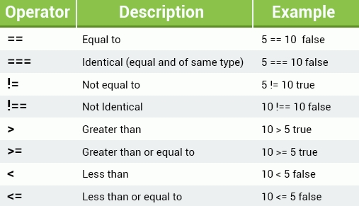

**Heads up!**  
One important thing to remember when we use operators, is that they only work when they’re comparing the **same data type**; numbers with numbers, strings with strings, you get the idea.

**Logical Operators**

**Logical**Operators, also known as **Boolean**Operators, (or the Vulcan Operators….ok, that one isn't **true**) evaluate an expression and return true or **false**.  
  
Check out the table below to see more details on the logical operators (**AND**, **OR**, **NOT**).

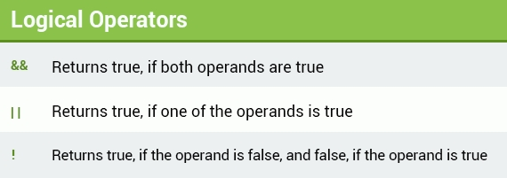

**Heads up!**  
You can check all types of data; comparison operators always return true or false.

# Logical Operators

Let's take a look at an example. Here we’ve connected two Boolean expressions with the **AND**operator.

(4 > 2) && (10 < 15)

For this expression to be **true**, both conditions need to be **true**.  
- The first condition determines whether 4 is greater than 2, which is **true**.  
- The second condition determines whether 10 is less than 15, which is also **true**.  
  
Ta da! The whole expression is **true**...very logical!

## Conditional (Ternary) Operator

**Conditional**, or **Ternary**, **operators** assign a value to a variable, based on some condition.  
  
This is what the syntax would look like:

variable = (condition) ? value1: value2

**And here’s an example:**

var isAdult = (age < 18) ? "Too young": "Old enough";

If the variable age is a value below 18, the value of the variable isAdult will be "Too young". Otherwise the value of isAdult will be "Old enough".

**Heads up!**  
With logical operators you can connect as many expressions as you want or need to.

**String Operators**

Time to introduce the most useful operator for strings...drum roll please.  
  
...**Concatenation**.  
  
We can use concatenation (represented by the + sign) to build strings made up of multiple smaller strings, or by joining strings with other types. Check it out:

var mystring1 = "I am learning ";   
var mystring2 = "JavaScript with SoloLearn.";   
document.write (mystring1 + mystring2);

This example declares and initializes two string variables, and then concatenates them. Simple...but super useful!

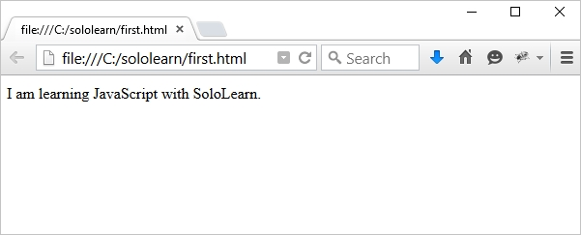

**Heads up!**  
Numbers in quotes are treated as strings: So "42" is not the number 42, it’s a string that includes the two separate characters, 4 and 2.